**Component Name**: Voice command recognition

**Component Functionality**:

The main moto of this app is it transmit speech to text recognition. As soon as the page loads we display all the data in the form of data table. So, based on the click of mic icon user would be able to provide input so as to filter the data. And this filter happens through out all the fields in the table and also recognizes the digits and clears the data when the mic icon is clicked back.

**Usage Areas**:

As it’s a reusable component can be used as a shared module wherever required.

**Component Technical details**:

* Angular cli version: 8.2.5
* Typescript version: 3.5.3
* rxjs version: 6.4.0

We have a single component with Speech Recognition Interface of Web Speech API library along with the datatable which is mocked to filter based on input provided.

**How this component can be integrated with other Applications**:

As we have used shared Modules so we need to just import the modules and selectors along with the web-speech folder so as to link to the web Speech API.

**Screenshots**:

1. **Initial screen**:

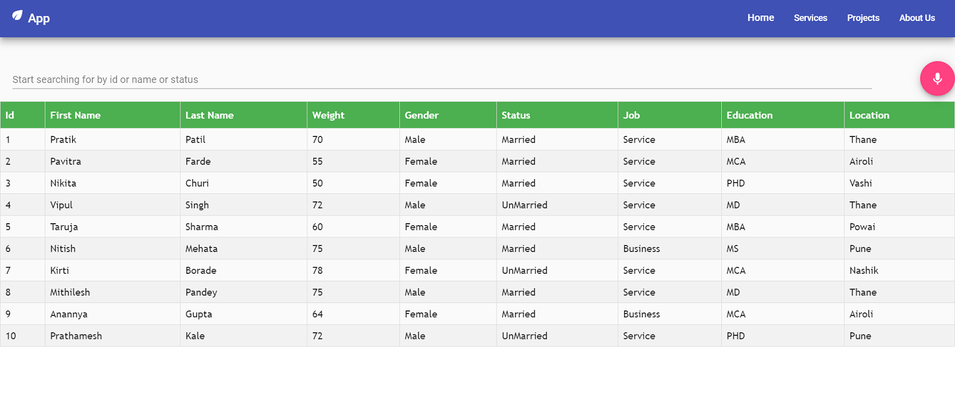

1. **When a user speaks, the text transmission happens and filters the data**

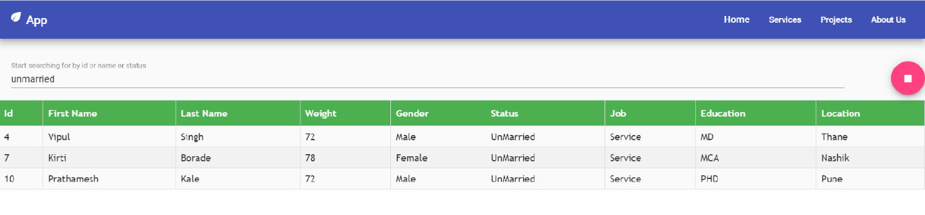

1. **Here, value is being matched with all the data fields:**

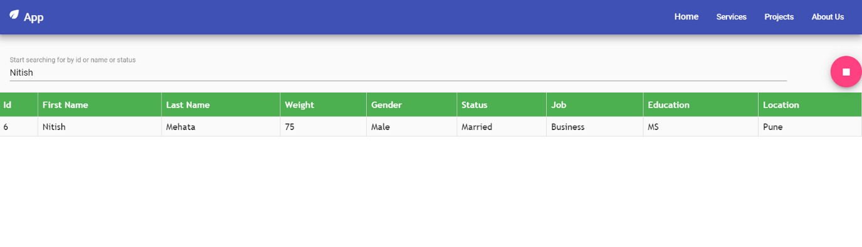

1. **Digits also transcript:**

